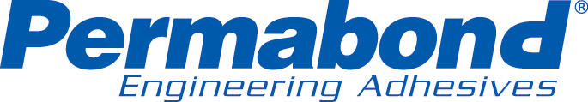
For immediate release
March 1, 2007

Editorial Contact: Technical Contact
Laurie Gibbons Manny Dias
Phone 860-379-9172 Phone 732-868-1372
laurie.gibbons@permabond.com manny.dias@permabond.com

Permabond Expands Structural Adhesive Line to Include Single Part Epoxies

SOMERSET, NJ – Permabond® Engineering Adhesives expands its structural adhesives line with five new one component epoxies. Each epoxy has high strength and high temperature resistance and all cure with heat. They vary in viscosity, color, gap fill and cure speed. These products were added for ultimate heat resistance for structural bonds and for applications in which a one-component process is desirable.

Permabonds line of structural adhesives includes one and two component epoxies and toughened acrylic adhesives. And, although not generally considered structural adhesives, Permabonds UV curable adhesives for glass to metal provide structural strength bonds for furniture and staircase bonding.

Permabond is a global manufacturer of engineering adhesives and sealants for manufacturing, assembly, repair and maintenance. In addition to structural adhesives, Permabond manufactures cyanoacrylates, (instant adhesives) and anaerobics (for threadlocking, retaining, gasketing and pipe sealing). Permabond products are sold worldwide through authorized distributors.

For information or a copy of the new technical literature, please contact Permabond by mail: 20C World’s Fair Drive, Somerset, NJ 08873; phone: 800-640-7599; fax: 800-334-3219 or email: help.americas@permabond.com. You may also visit our website at www.permabond.com.
# # #

