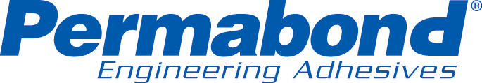
For immediate release
August 6, 2009

Editorial Contact: Technical Contact
Laurie Gibbons Manny Dias
Phone 860-379-9172 Phone 732-868-1372
laurie.gibbons@permabond.com manny.dias@permabond.com

Permabond 791 Meets Commercial Standard A-A-3097 Type II Class 1

SOMERSET, NJ –Permabond® Engineering Adhesives 791 was tested and met and the specifications for Commercial Standard A-A-3097 Type II Class 1. Permabond 791 is a surface insensitive cyanoacrylate (instant adhesive). Surface insensitive cyanoacrylates cure faster on acidic and porous surfaces. 791 is a low viscosity adhesive, very fast curing adhesive which is ideal for applications involving close fitting components. The exceptional tensile strength and very high shear strength lend Permabond 791 to applications that previously required a slower curing structural adhesive.

Permabond 791 is one of many cyanoacrylates Permabond has tested to commercial standards. “Engineers are requesting the commercial standards for new applications and the MIL-Specs for existing designs. Permabond continues to test products to stay current with the required standards and specifications of industry.” Manny Dias, Technical Manager, Permabond.

Permabond is a global, ISO 9001:2000 certified manufacturer of engineering adhesives and sealants for manufacturing, assembly, repair, and maintenance. Permabond manufactures cyanoacrylates (instant adhesives), anaerobics (for threadlocking, retaining, gasketing and pipe sealing), structural adhesives (one or two component epoxies and toughened acrylic adhesives), and UV - visible curable adhesives. Permabond custom formulates for unique requirements. Permabond products are sold worldwide through authorized distributors.

For information please contact Permabond by phone: 732-868-1372 or 800-640-7599; fax: 800-334-3219; info.americas@permabond.com or by mail: 223 Churchill Ave., Somerset, NJ 08873. Visit our NEW website at www.permabond.com
# # #

